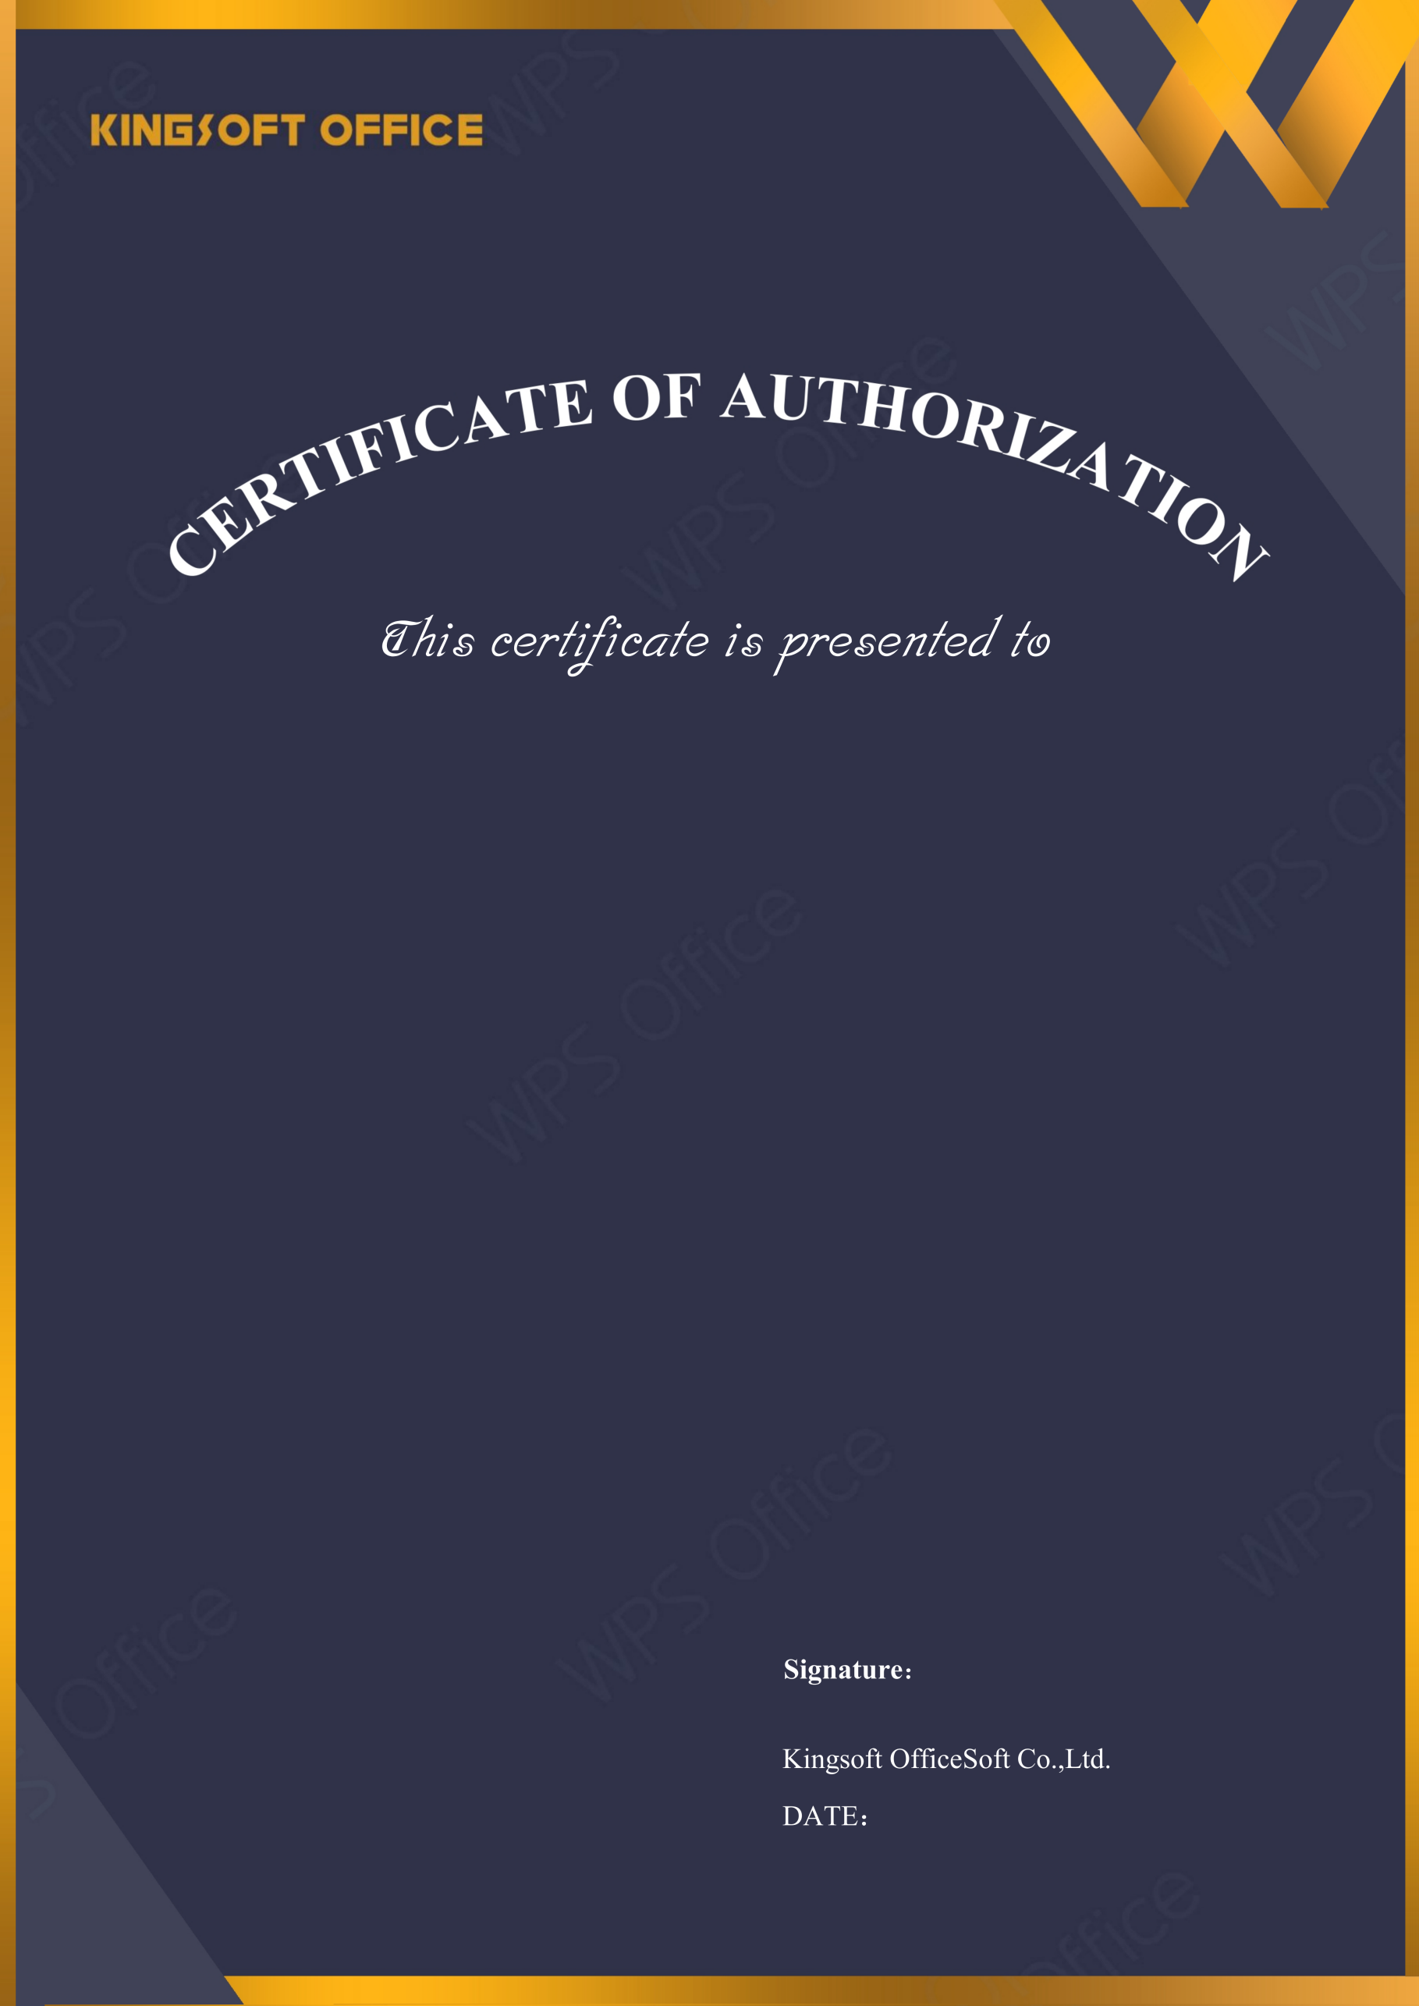
2026-05-06
Euro Creations Public Company Limited

Licensed Software: | WPS Pro
License Type: | WPS Pro - 11 Year
Licensed Quantity: | 11
Activation Deadline: | 2027-05-06
Upgrade Deadline: | 2027-05-06
License Number: | GZU1T-MHZ16-4CEG8-MXGXB-G6HVW-A6AVI



